Chapter 3, Solution 2

At node 1,

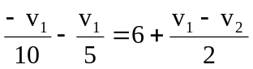 60 = - 8v₁ + 5v₂ (1)

At node 2,
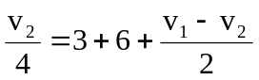 36 = - 2v₁ + 3v₂ (2)

Solving (1) and (2),

v₁ = 0 V, v₂ = 12 V

